21th Annual CFD Symposium, August 8-9, 2019, Bangalore

numerical simulation of store sepAration using different mesh types in overset meshing approach

**Alok Khaware1, Arun Kumar1, Vinay Kumar Gupta1, Krishna Zore1**

**1**ANSYS Inc., Pune, India, 411057

Abstract

*Numerical simulation of store separation is validated against experiment using different types of meshes in overset meshing approach. Overset mesh provides a flexibility to create independent zonal meshes which can overlap on each other and move independently, grid connectivity establishes through strong interpolation methods. Overset approach allows avoiding the mesh deformation in moving dynamic problems thus maintaining the grid quality throughout the simulation. The accuracy of the solution is dependent on the interpolation at the overset interface. In this paper, the EGLIN test [1] is solved using overset approach and validated for Tetrahedral mesh, Polyhedral mesh, Hexcore mesh, and Polyhedral-Hexcore mesh. The performance study is conducted for all types of meshes, results are compared, and best practices are concluded. The density-based coupled solver implemented in ANSYS Fluent along with Six degrees of freedom (6DOF) rigid body dynamic solver is applied to solve compressible flow equations for predicting the projectile motion of the store.*

Keywords: Overset Mesh, Store Separation, Eglin Test, Tetrahedral Mesh, Polyhedral Mesh, Hexcore Mesh, Poly-Hexcore Mesh.

Nomenclature

Ma= Mach number

Cm = center of mass

C.G = center of gravity

*Cp*= pressure coefficient

= rotations about Z axis (yaw)

 = rotations about Y axis (pitch)

 = rotations about X axis (roll)

 = angle between Z axis and cross section monitor lines

1. INTRODUCTION

The store separation process from an aircraft requires a detailed analysis because of the safety measures, and most often the store is ejected at a high speed to avoid collision between the store and the aircraft. Numerical analysis has become a common practice as an experimental setup for this kind of problems are very expensive and time-consuming. Several approaches were traditionally used to simulate this class of moving dynamics problems which includes quasi-steady [2], dynamic mesh [3], and overset mesh [4]. Quasi-steady analysis predicts the motion only at an instantaneous location and fails to provide continuous motion history of the store. Dynamic mesh approach provides continuous motion history but maintaining the quality of the mesh for the desired accuracy during the simulation is a challenge due to the deformation of the mesh elements to accommodate general body motion. The dynamic mesh also requires a large effort in mesh preparation for complex geometries. Overset mesh, by allowing the decomposition of the task of meshing to individual components, potentially simplifies the overall mesh generation. If the same object is present multiple times in the domain, then overset approach allows to create mesh once for the object and use the same for multiple times. Furthermore, the quality of the mesh is preserved for bodies undergoing general motion. The speed and accuracy depend on the characteristic of the mesh, different mesh elements are required to resolve different geometries and flow regimes to deliver optimal performance.

1. Overset Mesh

In the overset method, a complex computational domain is sub-divided into several components. These components are meshed and overlapped to build connectivity with each other. As this method is based on independently floating overlapping mesh components, it is possible to move or replace a specific component grid and create a new flow domain. This advantage can be used for the problems where shape design studies are performed or moving boundary is present.

In this method, the mesh connectivity is built for each cell and its neighbors from the same or different components. The hole-cutting process is carried out to identify the approximate representation of the overset wall boundary by utilizing cutting surface and to mark all points inside the boundary and outside the computational domain as the hole-points or dead-cells. Once boundaries are marked, a flood-filling algorithm is applied to points inside the wall boundaries. Once overset boundaries are established, the donor search process begins, receptor cells and donor cells are established. After each point has been assigned a property, interpolation weights for each receptor cell associated with a donor cell are computed. The interpolation weights are calculated first based on mesh connectivity information. The receptor cells receive information from the neighboring donor cells based on either face connectivity or node connectivity. Receptor cell values are updated by the interpolation method followed by computation of reconstruction and viscous gradients. The gradients are either interpolated directly or computed from the interpolated solution data. Though ANSYS Fluent provides two interpolation methods, the Least Square method is more accurate than the Inverse Distance method [5]

In overset interpolation method, receptor cells at the overset interface receive information from multiple donors, which are interpolated as below [6]

$$φ^{h}=\sum_{i=0}^{N_{d}}{w^{i}φ^{i}}$$

Where, is the interpolation weights,  is the solution variable and is the number of donors.

Figure 1 shows two grids overlapping on each other and connected through an overset interface.

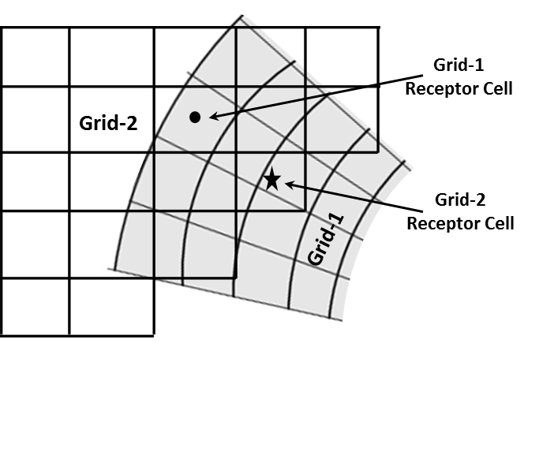**FIGURE 1:** OVERLAPPING GRID-1 AND GRID-2 AT OVERSET MESH INTERFACE

1. **EGLIN TEST CASE** **FOR STORE SEPERATION**

**3.1 Test Case Description**

EGLIN test was first conducted at the Arnold Engineering Development Center in the Aerodynamic Wind Tunnel (4T) in 1990 [1]. EGLIN test model consists of three parts; the first is a delta wing of constant NACA 64A010 airfoil section with 45°sweep, the second is a pylon with an ogive-flat plate-ogive cross-section shape, and the third is a finned store body of ogive-cylinder-ogive shape. The trailing edge of the wing has no sweep angle and has a taper ratio of 0. 133. There are four identical fins on the store consisting of a clipped delta wing of a constant NACA 0008 airfoil section with a 45° sweep. Leading and trailing edge sweep angles of fins are 60 degrees and 0 degrees, respectively. The gap between the pylon and the finned body is 1.778 mm. The length and diameter of the store are 3017.5 mm and 508.1 mm, respectively.

The store is ejected with a force to commence a safe initial separation for a duration of 0.054 s until it falls for 100.584 mm, and later, its motion is subjected to gravity and aerodynamic forces. Ejector locations and center of gravity of the store are shown in Figure 2. Store mass, inertial properties, and ejector parameters are tabulated in Table 1.

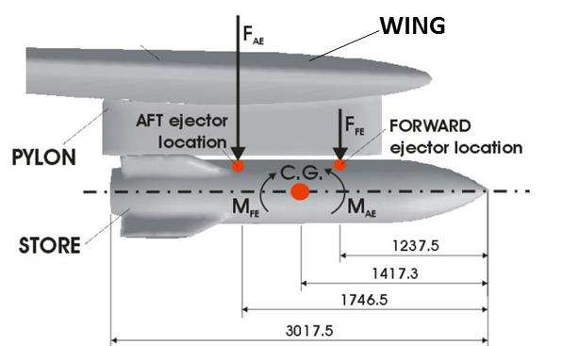

**FIGURE 2:** MODEL DIMENSIONS AND EJECTOR FORCE

**TABLE 1:** GEOMETRICAL DATA AND EXPERIMENTAL INPUTS FOR THE EGLIN TEST CASE

|  |  |
| --- | --- |
| Mass | 907.1847 kg |
| Center of Mass, Cm | 1417.3 mm  (aft of store nose) |
| Roll Moment of Inertia, IXX | 27.1163 kg-m2 |
| Pitch Moment of Inertia, IYY | 488.0944 kg-m2 |
| Yaw Moment of Inertia, IZZ | 488.0944 kg-m2 |
| Forward Ejector Location | 1237.5 mm  (aft of store nose) |
| Aft Ejector Location | 1746.5 mm  (aft of store nose) |
| Forward Ejector Force, FFE | 10.6757 k-N |
| Aft Ejector Force, FAE | 42.7029 k-N |

**3.2 Computational Model**

The computational domain is scaled 20 times as the experimental model is based on a 1/20th scale of the actual geometry [7]. A half symmetry model is prepared for delta wing section. A frictionless sting is used in the experiment to hold free fall of the store which is not considered in this simulation. Two cell zones have been created considering overset requirements, one is the stationary background including wing and pylon and the other for moving store component.

Rotations about Z-axis (yaw), rotation about Y-axis (pitch) and rotation about X-axis (roll) are shown in Figure 3. Sign conventions in CFD simulation are kept same as experiments.

.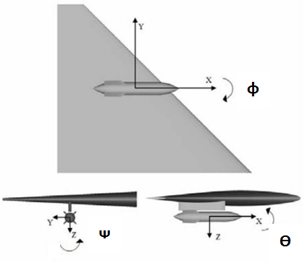

**FIGURE 3: $φ$**  , $θ$ AND $ψ$ ARE YAW PITCH AND ROLL ANGLES

1. **OVERSET MESH PREPERATION**

ANSYS Fluent Meshing offers to create Tetrahedron elements, Polyhedron elements, conventional Hexcore mesh, and a new mesh called Mosaic mesh or Poly-Hexcore. A well resolved triangular surface mesh is created on store, pylon and wing surfaces as an initial mesh. In Polyhedral and Poly-Hexcore meshing, it creates poly elements on the surface from initial triangular elements. Figure 4 shows the tri and poly surface mesh elements on the store.

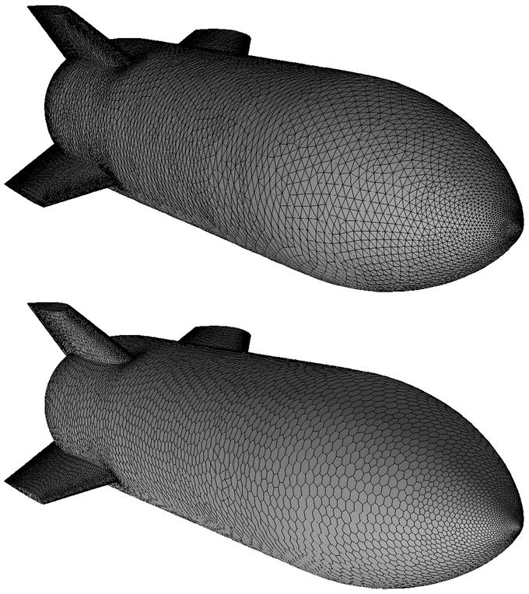

**FIGURE 4:** TRIANGULAR AND POLY MESH ON STORE SURFACE

The first case is created with Tetrahedral elements in the domain for background and component along with ten prism layers on all the walls. Total 6.81M elements are generated in tetrahedral mesh case among which 6.66M cells are active or solve cells and 0.15M cells became dead cells or inactive cells after overset mesh intersection. Minimum orthogonal quality is 0.4 and the average orthogonal quality is almost 0.8. Figure 5 shows the mesh around the store-pylon assembly along with the overset interface for Tetrahedral mesh case.

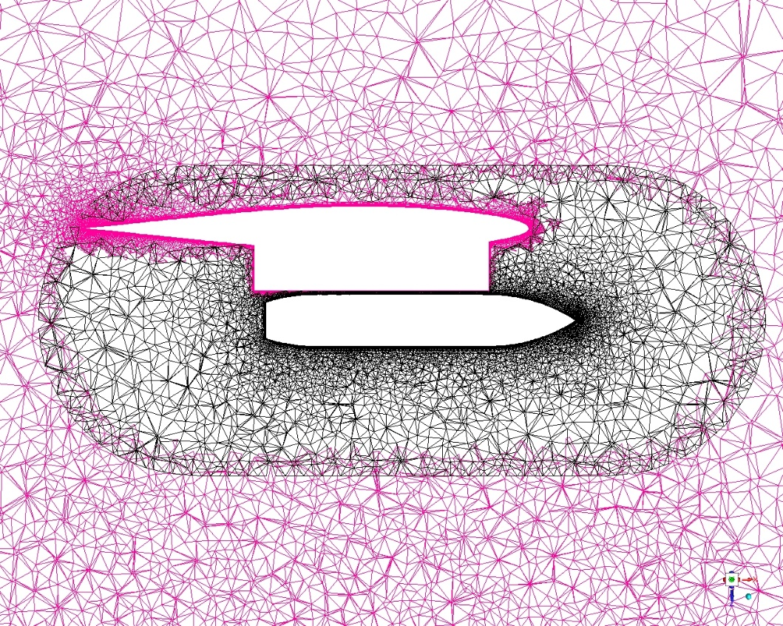

**FIGURE 5:** TETRAHEDRAL MESH AROUND STORE AND WING

The second case has meshed with Polyhedral cell elements in the bulk domain and the same number of inflation layers as the first case at walls. Total 2.41M elements are present in Polyhedral case where around 15K cells became inactive after the overset intersection. Minimum orthogonal quality of mesh is 0.1 where the average is 0.97. Figure 6 shows the mesh around the store-pylon assembly along with the overset interface for Polyhedral mesh case.

**FIGURE 6:** POLYHEDRAL MESH AROUND STORE AND WING

The third case has solved with the conventional Hexcore mesh using the same tri surface mesh applied in Tetrahedral case. In conventional Hexcore mesh, hexahedron elements present in the bulk, tetrahedron elements are created between wedge-prism and the bulk. Total 5.1 M mesh elements generated with 10 layers of inflations on the wall where 35K cells are dead cells after the overset intersection. Minimum orthogonal quality of the mesh is 0.045 and the average is 0.9. Figure 7 shows the mesh around the store-pylon assembly along with the overset interface for Hexcore mesh case.

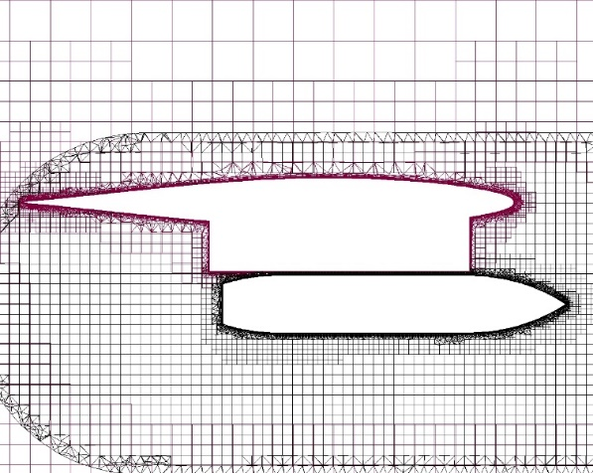

**FIGURE 7:** HEX-CORE MESH AROUND STORE AND WING

The fourth case meshed with Poly-Hexcore mesh also called Mosaic meshing implemented in ANSYS Fluent software. In poly-hex-core mesh, it fills the volume region with octree hexahedron, boundary layer with the high-quality layered poly-prism and conformally connects these two meshes with general polyhedron elements. Same surface mesh as tetrahedral case is used in int the case. Total 3.46 M mesh elements generated with 10 layers of inflations on the wall where 28K cells are dead cells after overset intersection. Minimum orthogonal quality of the mesh is 0.1 and the average is 0.97. Figure 8 shows the mesh around the store-pylon assembly along with the overset interface for Poly-Hexcore mesh case.

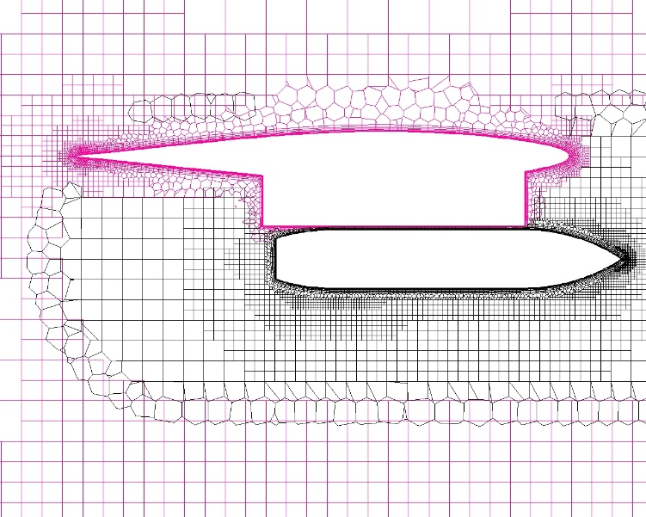

**FIGURE 8:** POLY-HEXCORE MESH AROUND STORE AND WING

Background is refined in the store dropping vicinity as shown in the Figure9.

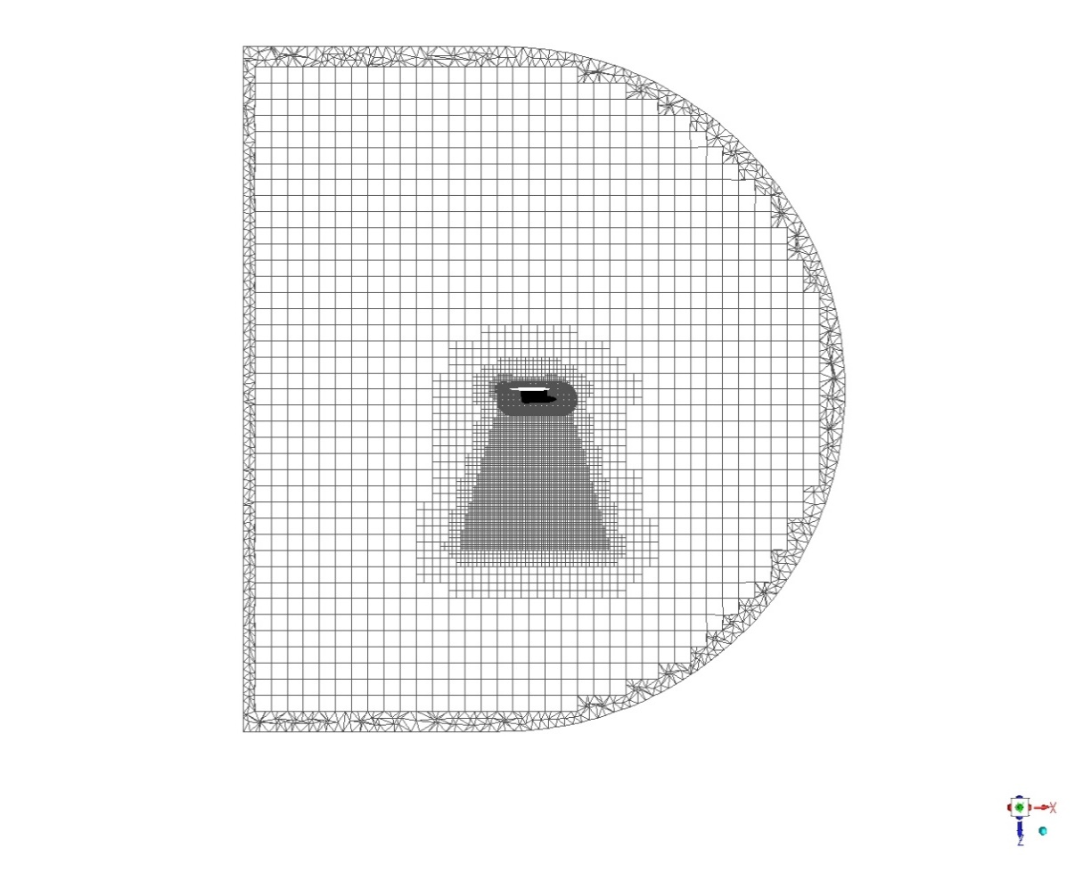

**FIGURE 9:** HEX-CORE MESH AT THE VERTICAL PLANE PASSING THROUGH THE STORE

Figure 10 shows the receptor (blue), donor (red) and solve (green) cells in the small gap between store and pylon at the initial condition. In the picture, cells are marked only for the background zone (A), only for the component zone (B) and background and component zone together (A + B). The growth of prismatic cells from pylon and component walls allowed to have sufficient overlap between component and background zone in the small gap region.

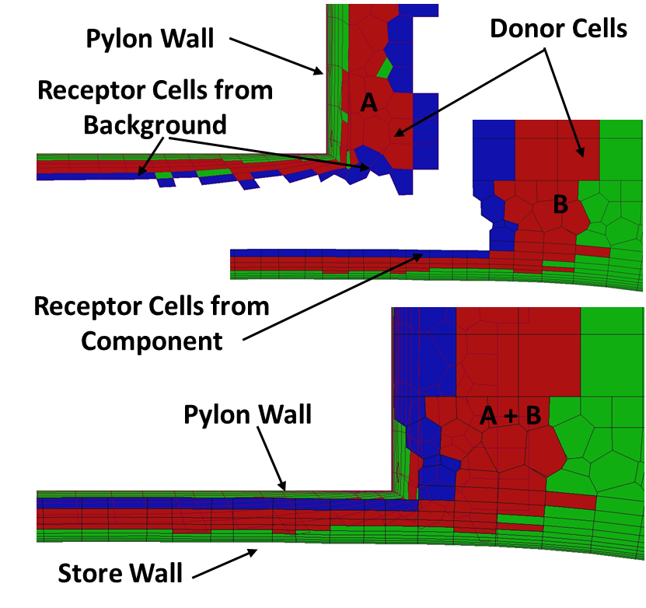

**FIGURE 10:** DONOR AND RECEPTOR CELLS FROM BACKGROUND AND COMPONENT

1. **BOUNDARY CONDITIONS**

In the experiment, a transonic regime with a Mach number of 0.95 and a supersonic regime with a Mach number of 1.2 was studied. The present study considers store separation at transonic (Ma=0.95) regime. Exploiting the symmetry of the geometry only one wing is modeled. A far-field boundary condition is applied upstream of the store assembly to simulate the free stream conditions, while a pressure outlet boundary condition is applied at downstream. SST k-omega turbulence model is applied for turbulence closure. Rigid body motion settings are defined for the store wall. The component zone attached to the store is also given a passive rigid body motion attribute to ensure it follows the store.

The wind tunnel free-stream Reynold number is 2.4 million [1]. This is used to calculate the viscosity of the fluid for respective Mach number. The ideal gas equation is obeyed for this case. Air properties are tabulated in Table 2.

**TABLE 2:** FREE STREAM FLOW QUANTITIES

|  |  |
| --- | --- |
| Flow Speed, Ma | 0.95 |
| Altitude, m | 7924.8 |
| Pressure, Pa | 35988.8 |
| Temperature, K | 236.639 |
| Density, kg/m3 | 0.5298364 |
| Velocity, m/s | 292.85 |
| Viscosity, Pa.s | 4.725 x 10-5 |
| Acceleration due to gravity, m/s2 |  |

1. **SOLVER METHODS**

The density-based coupled solver with the implicit formulation is used along with second order upwind discretization in space and second- order-backward-Euler in time. Least squares method is employed for special gradient calculation as well as for the overset interpolation weights. A fully developed steady-state solution is used as an initial condition for the transient analysis. The Courant number of 1 is used for the initial few timesteps and later increased to 10, as per best practices [6]. The residuals are converged till 1e-04. A temporal study is carried out to find the optimum speed with reasonable accuracy.

1. **RESULTS AND DISCUSSIONS**

The wind tunnel measured pressure coefficient data is available for comparison at multiple locations on the store surface. Figure 11. depicts similar locations in the computations.

First, the steady RANs calculations are performed on all the mesh variants, which then used for initializing transient URANs calculations. Figure 12 shows the pressure coefficient contour on the store and pylon obtained with steady RANs computation on Hexcore and Poly-Hexcore mesh. Next, from the URANs calculations the store position and the angular orientation are compared and validated against the measurements at different time instance. Figure 13 shows the computational position and orientation of the store at different time instances, while dropping from the aircraft bay.

Furthermore, Figure 14 and Figure 15 show the center of gravity (CG) orientation and angular orientation at different time instants compared with the measurements for multiple mesh variants respectively. The falling store CG and angular orientation in all the X, Y and Z coordinate axis directions shows good agreement with the experimental measurements with all the mesh variants.

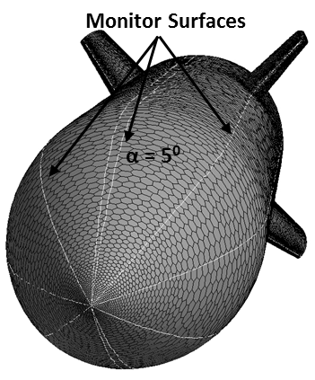

**FIGURE 11:** MONITOR LINES AT DIFFERENT ANGLES (α = 00, 50, 450, 950, 1350)

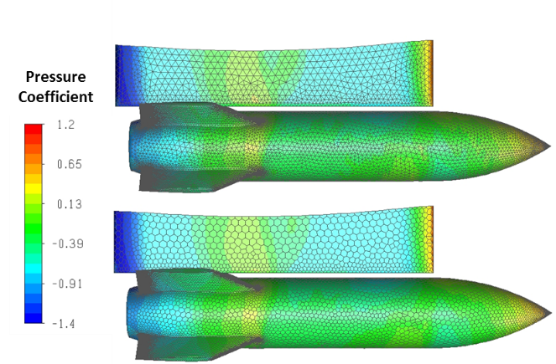

**FIGURE 12:** PRESSURE COEFFICIENT DISTRIBUTION FOR HEXCORE CASE AND POLY- HEXCORE CASE

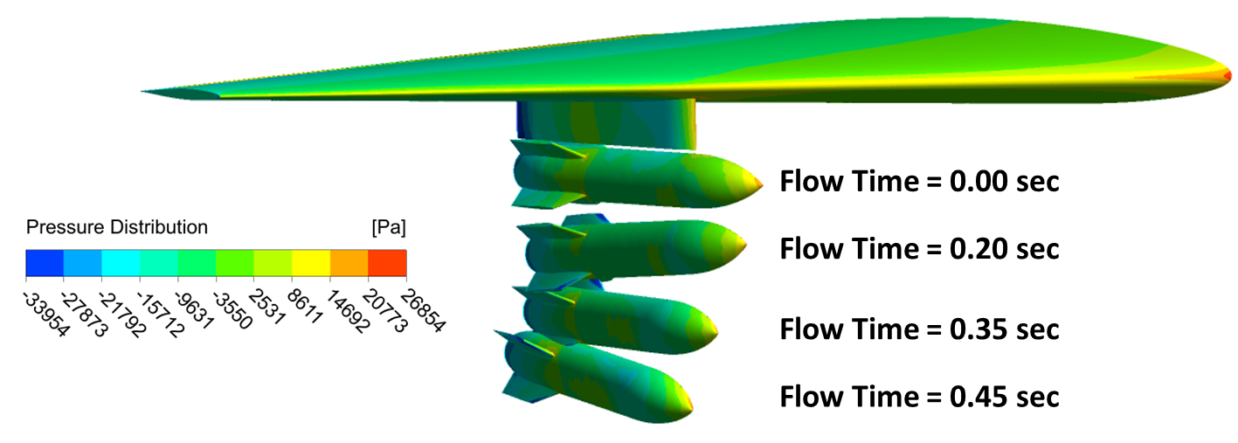

**FIGURE 13:** POSITION AND ORIENTATION OF STORE AT DIFFERENT TIME

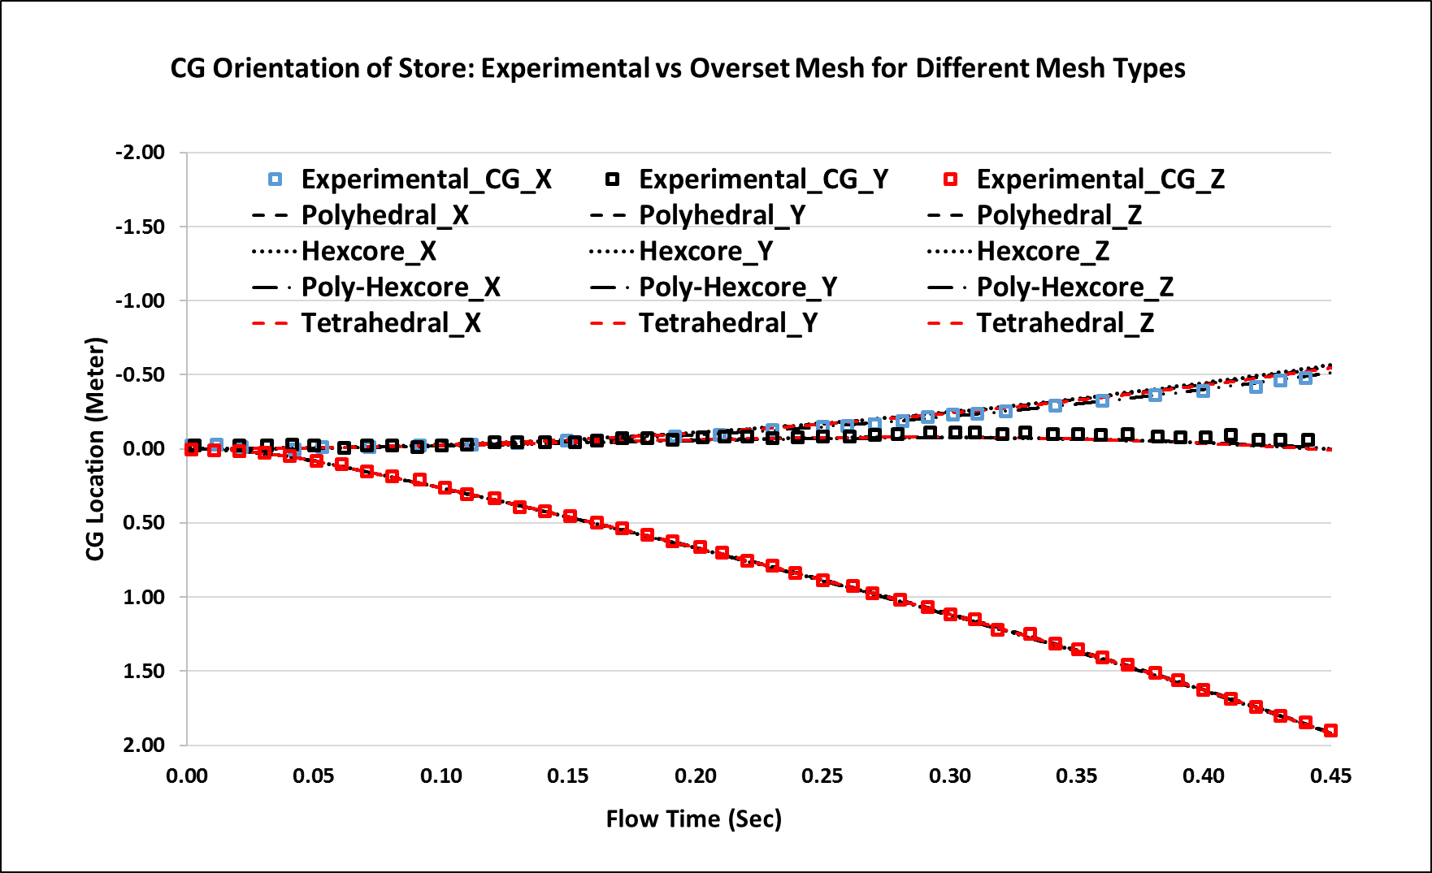

**FIGURE 14:** CG ORIENTATION OF STORE AT DIFFERENT TIME FOR DIFFERENT TYPES OF MESHES

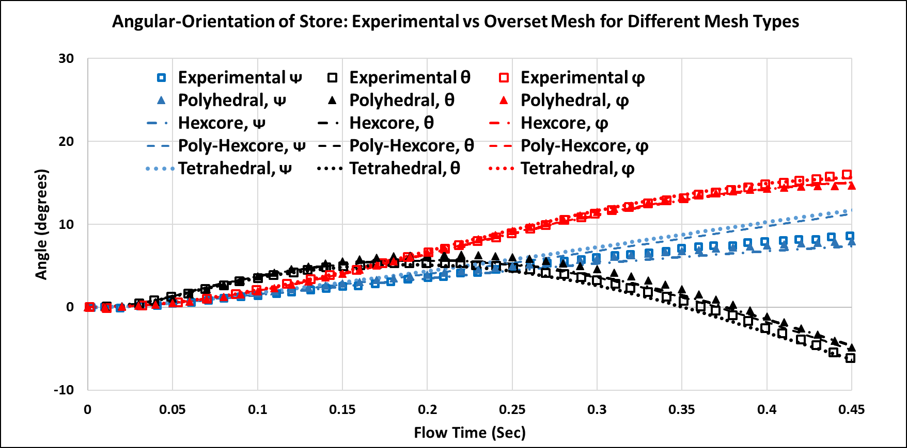

**FIGURE 15:** ANGULAR ORIENTATION OF STORE AT DIFFERENT TIME FOR DIFFERENT TYPES OF MESHES

While the store gets separated, the nose of the store pitches up for some time due to the initial ejector forces (t = 0.06 s) and later store nose pitches down due to the action of aerodynamic and gravity forces. The inward trajectory of the store stops after t = 0.32 s when it is close to 1.3 meters away from the pylon. Substantially, the store exhibits rolling and yawing motion outward towards the wing tip. There is some deviation seen on angular orientation especially for Yaw motion (ᴪ) on Tetrahedral and Poly-Hexcore meshes compared to other meshes. Roll and Pitch motion paths are following the experimental.

The coefficient of pressure is plotted at an angular measuring location of 5 degrees (α = 50) on the store surface and compared with experimental data for multiple time instances (t = 0.00s, t = 0.17s and t = 0.32s) on all the mesh variants, as shown in Figure 16, Figure 17 and Figure 18 respectively. Initial time instance t=0.00s shows very good match between computations and experiment. Next time instances t=0.17s and t=0.32s shows some deviation on poly mesh at the middle section of the store however, overall pressure coefficient distribution is reasonable and show good trend with experiment, with further scope in improvement with mesh refinement.

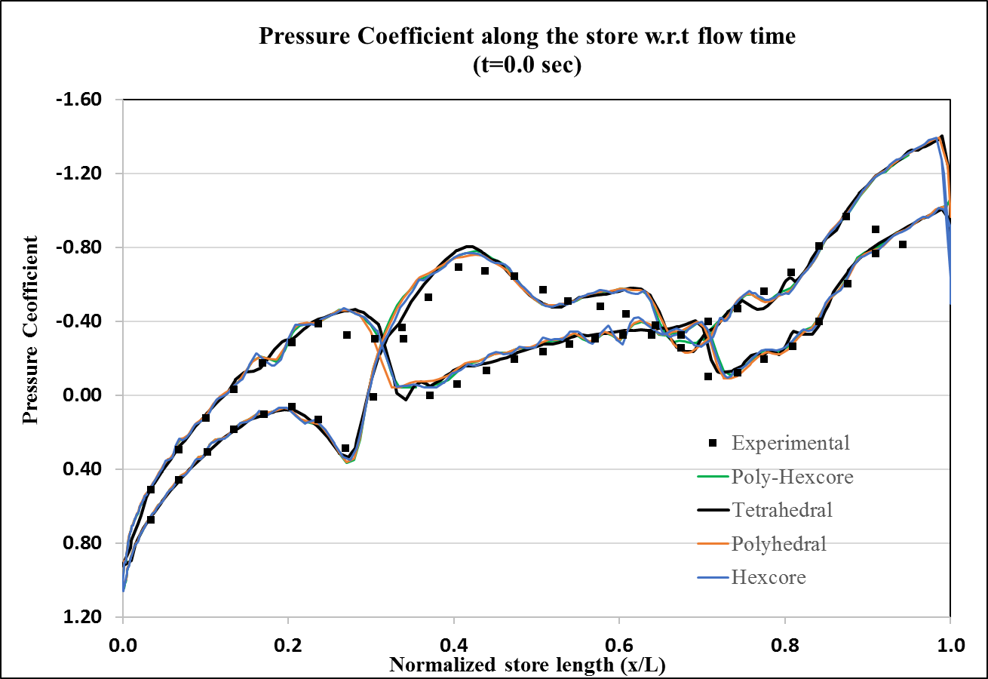

**FIGURE 16:** PRESSURE COEFFICIENT AT t = 0.0s

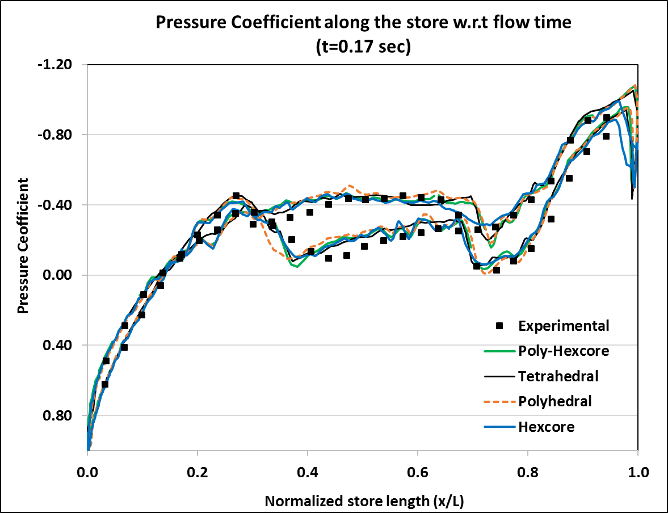

**FIGURE 17:** PRESSURE COEFFICIENT AT t = 0.17s

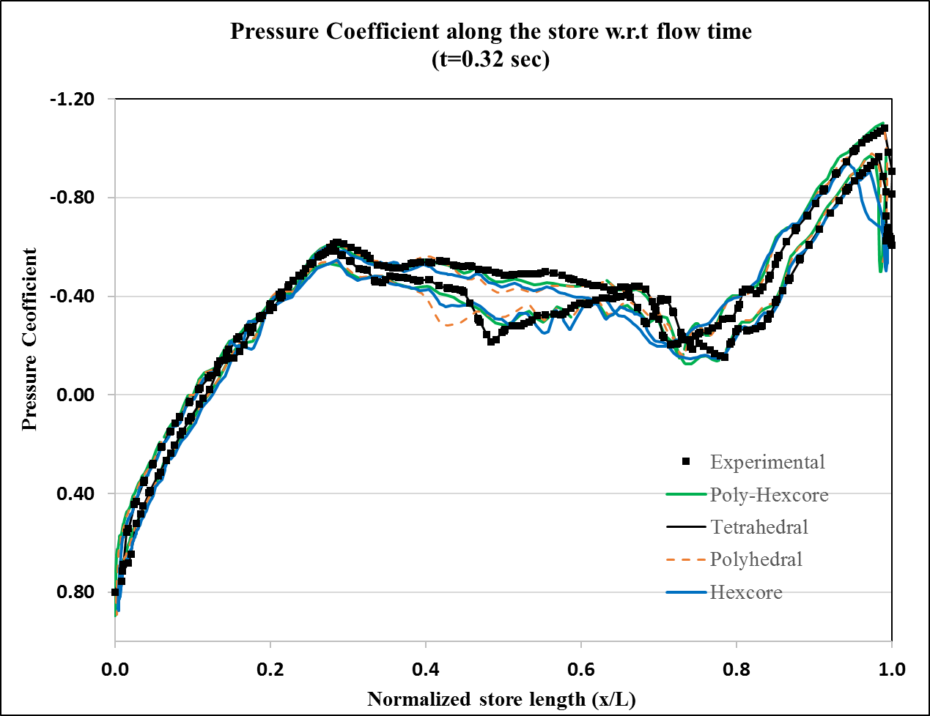

**FIGURE 18:** PRESSURE COEFFICIENT AT t = 0.32s

Solver performance study is carried out for all the mesh variants on 64 cores machine. The total physical time 0.5s was simulated with multiple timestep size, varying from 1e-4s, 1e-3s, and 1e-2s, based on the flow CFL, 0.4, 4, and 40 respectively.

As shown in the 3D Chart (Figure 19), for the finest timestep size 1e-4s, the Tetrahedral, Polyhedral, Hexcore and Poly-Hexcore takes 122.6hr, 97hr, 113hr and 105hr, respectively to complete 0.5s of flow time. Similarly, for medium timestep size 1e-3s, these meshes takes 98.5hr, 35hr, 56hr and 47hr, respectively. Further, only Polyhedral mesh is successful on coarse timestep size 1e-2s, giving converge solution, all other meshes resulted in solver divergence at this timestep. Thus, the Polyhedral and Poly-Hexcore mesh topologies are beneficial compared to other mesh topologies from solver performance point of view and the best choice for these types of applications.

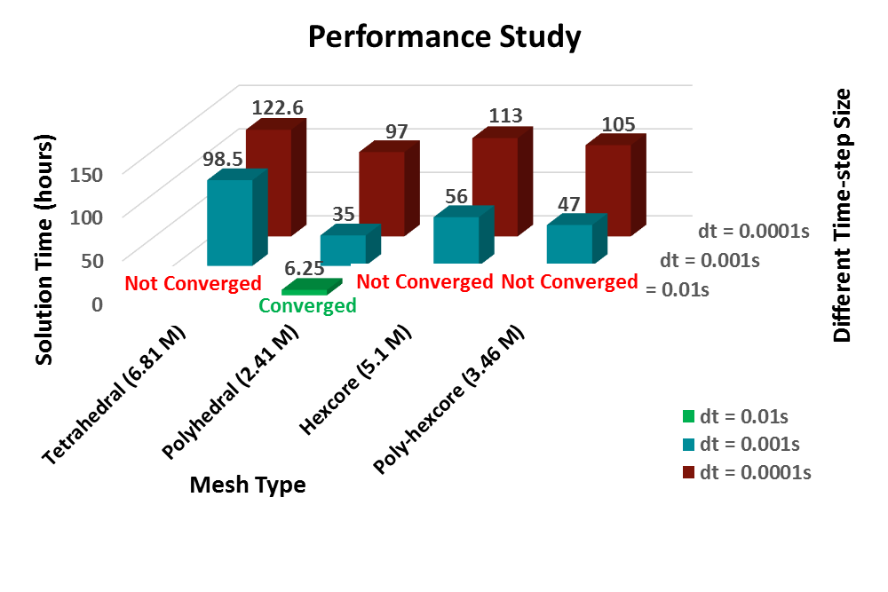

**FIGURE 19:** SOLUTION TIME FOR DIFFERENT MESH TYPES USING DIFFERENT TIMESTEP SIZE

Furthermore, the Polyhedral mesh solution is analyzed and compared for different timestep size to make sure that the reasonable solution accuracy is achieved. Figure 20 and Figure 21 show the CG location and angular orientation of the store for different timestep size on Polyhedral mesh. Figure 22 shows the pressure coefficient along the store angular measuring location 5 degrees (α = 50), at measuring time instant t=0.17s and timestep size of 0.001s and 0.01s respectively. It can be seen that the pressure coefficient with the coarsest timestep size of 0.01s are very similar to 0.001s and matches well with the experiment.

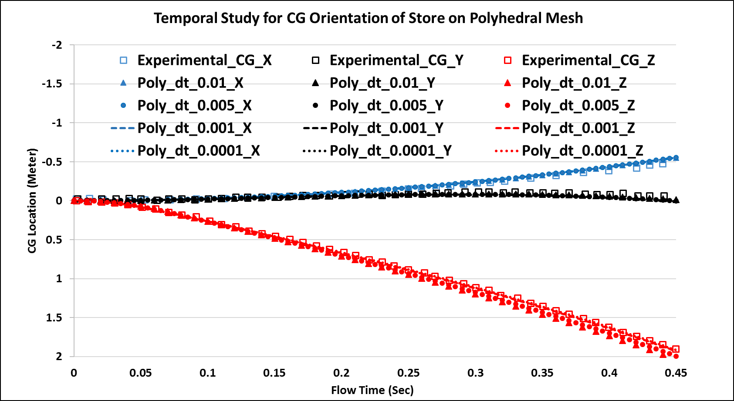

**FIGURE 20:** POSITION AND ORIENTATION OF STORE AT DIFFERENT TIME

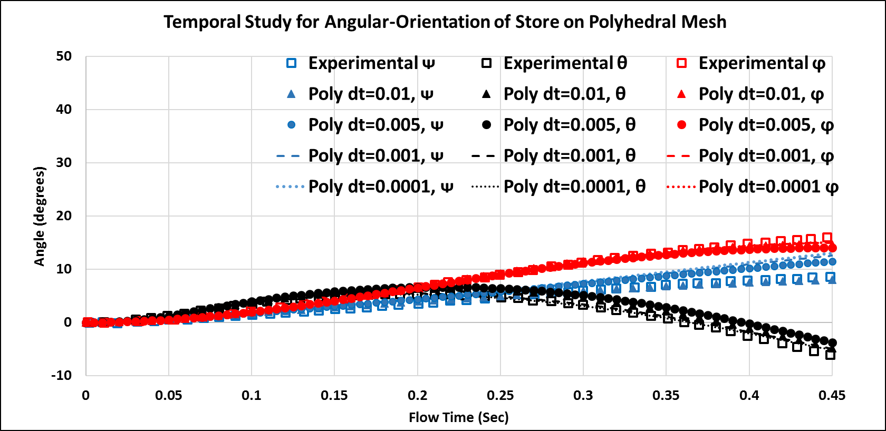

**FIGURE 21:** POSITION AND ORIENTATION OF STORE AT DIFFERENT TIME

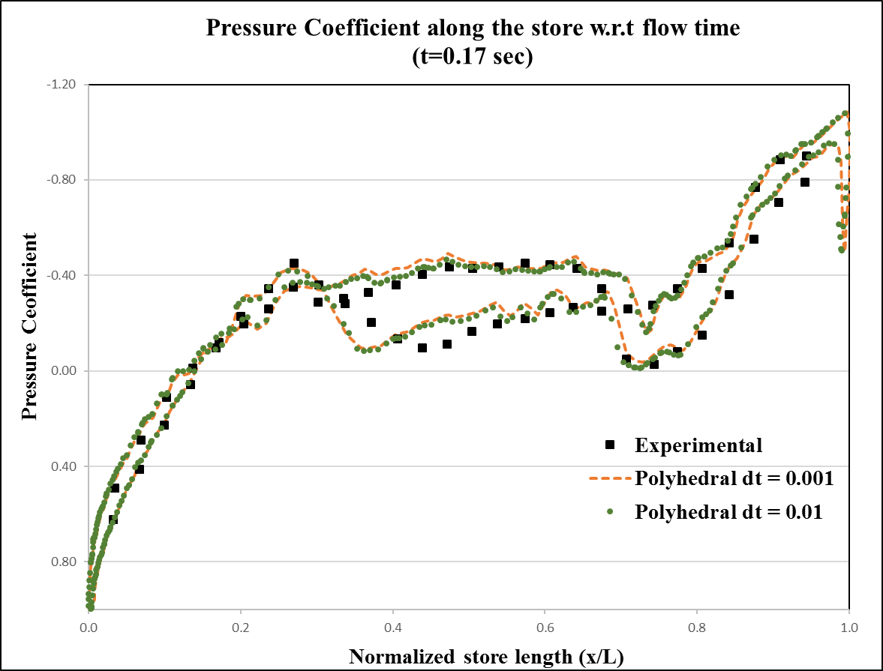

**FIGURE 22:** PRESSURE COEFFICIENT AT t = 0.17s FOR TIMESTEP SIZE OF 0.001s AND 0.01s

1. **CONCLUSION**

In this paper, the overset meshing approach implemented in ANSYS Fluent is applied to solve store separation from a delta wing and validated against the EGLIN experiment [1]. The trajectory and orientation of the store obtained from the CFD solution are compared with the experimental results for the transonic flow regime. The pressure coefficient distribution along the store are also validated against experiment for different time instances during store drop.

The test case is validated using Tetrahedral, Polyhedral, Hexcore, and Poly-Hexcore mesh and it is concluded that all the meshes work well for overset approach and produce close results. A temporal study is also conducted to obtain a faster solution and it is concluded that Polyhedral mesh variant could be used with large timestep size maintaining good accuracy. Overall solution time is reduced by 15 times compared to the Tetrahedral case by using Polyhedral mesh and larger timestep size.

**REFERENCES**

[1] HEIM, E.R.: CFD Wing/Pylon/Finned Store Mutual Interference Wind Tunnel Experiment, Arnold Engineering Development Center, AD-B152 669, September 10-17 1990.

[2] M. Jafari “Simulation of Store Separation using Low-cost CFD with Dynamic Meshing”, IJE TRANSACTIONS B: Applications Vol. 27, No. 5, (May 2014) 775-784

[3] Yunus Emre Sunay “Numerical Simulations of Store Separation Trajectories Using the EGLIN Test”; Scientific Technical Review, 2013, Vol.63, No.1, pp.10-16; UDK: 620.178:623.463.5, COSATI: 20-04, 16-02, 16-04

[4] R. Koomullil, G. Cheng, B. Soni, R. Noack and N. Prewitt. “Moving-body Simulations Using Overset Framework with Rigid Body Dynamics”. Mathematics and Computers in Simulation, 78(5-6):618-626, 2008.

[5] Ansys User Manual, Version: release 18.1, ANSYS, Inc

[6] Ansys Theory Manual, Version: release 18.1, ANSYS, Inc.

[7] Elias E. Panagiotopoulos & Spyridon D. Kyparissis “CFD Transonic Store Separation Trajectory Predictions with Comparison to Wind Tunnel Investigations” in International Journal of Engineering (IJE), Volume (3): Issue (6).